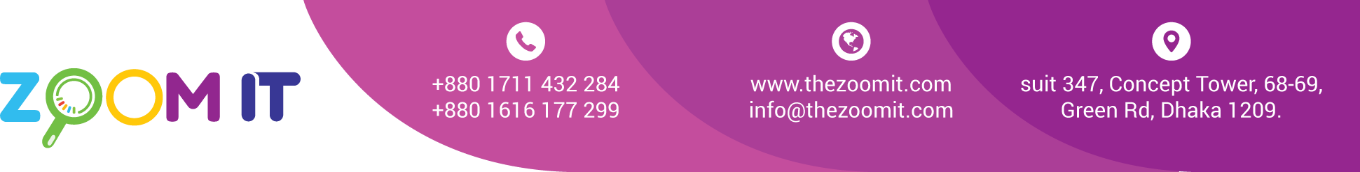

**Bill**

|  |  |
| --- | --- |
| Date | 10/12/2022 |
| INV. NO. | 10120 |

|  |  |
| --- | --- |
| Name | **Miyako Appliance Limited** |
| Address | Palton Dhaka. |

|  |  |  |  |
| --- | --- | --- | --- |
| **Sl.**  **No.** | **Description** | **task** | **Value in Taka** |
| 1 | Domain & Server renew bill | Yearly | 20,000 |
|  | | Total | 20,000 |
| Paid |  |
| Due |  |

BANK Details

Ac Name: ZOOM IT

AC NO: 1782112000003115

UCB bank  
  
Bkash 01711432284

Signature